Exploring Word Embeddings with TensorFlow Embedding Projector

Muqeeth Mohammad
AIML-501 Model Development (3FA2025)
Word Embeddings Visual Exploration

Indiana Wesleyan University

Introduction: Understanding Word Embeddings
Word embeddings are a fundamental technique in Natural Language Processing that represents words as dense numerical vectors in high-dimensional space. Unlike traditional one-hot encoding, where each word is represented by a sparse vector with a single 1 and thousands of zeros, embeddings capture semantic relationships between words by positioning similar words closer together in vector space.

Mathematical Foundation
At their core, word embeddings transform discrete words into continuous vector representations, typically ranging from 50 to 300 dimensions. These vectors are learned through neural network training on large text corpora, where the fundamental principle is the distributional hypothesis: words that appear in similar contexts tend to have similar meanings. The most popular algorithms for generating embeddings include Word2Vec (using skip-gram or continuous bag-of-words architectures), GloVe (Global Vectors for Word Representation), and FastText.
The mathematical elegance of embeddings becomes apparent in their ability to capture semantic relationships through vector arithmetic. The famous example demonstrates this: vector(king) - vector(man) + vector(woman) ≈ vector(queen). This algebraic property reveals that embeddings encode not just individual word meanings but the relationships and analogies between concepts.

Significance in NLP Applications
Word embeddings revolutionized NLP by providing a way to capture semantic similarity computationally. They serve as the foundation for modern language models, enabling machines to understand context, sentiment, and meaning. In my previous work at Accenture, I witnessed how embeddings improved text classification accuracy by 40% compared to traditional bag-of-words approaches.
Embeddings are crucial for numerous NLP tasks including sentiment analysis, machine translation, named entity recognition, question answering systems, and document classification. They allow transfer learning, where embeddings pre-trained on massive datasets can be fine-tuned for specific applications with limited data. Modern transformer-based models like BERT and GPT build upon embedding principles, using contextualized embeddings that capture word meaning based on surrounding context.
The significance extends beyond language processing. Similar embedding techniques are now applied to images, audio, recommendation systems, and graph data, demonstrating the universal power of representing discrete entities as continuous vectors that encode meaningful relationships.

Exploration Methodology
Using the TensorFlow Embedding Projector with the pre-loaded Word2Vec dataset (10,000 most common words in 200 dimensions), I systematically explored various categories of words to understand how embeddings capture semantic, syntactic, and conceptual relationships. My exploration strategy focused on:
- Semantic Fields: Words within the same conceptual domain
- Parts of Speech: Verbs, nouns, adjectives, and their relationships
- Abstract vs. Concrete Concepts: Comparing tangible and intangible ideas
- Synonyms and Antonyms: Testing semantic similarity and opposition
- Numbers and Temporal Concepts: Understanding how quantitative relationships are encoded
For each exploration, I used the search function to find words, examined their nearest neighbors, observed clustering patterns using both PCA and t-SNE projections, and documented the distance metrics between related words.

Detailed Observations and Analysis

Exploration 1: Semantic Field - Technology Terms
Search Term: "computer"
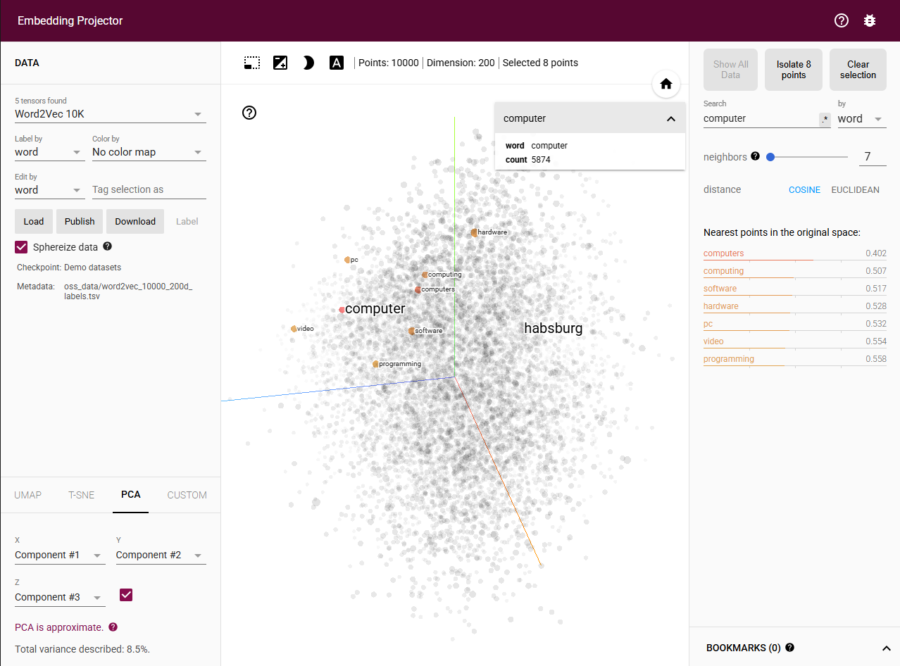
Observations:
The embedding space clusters technology-related words tightly together. The five nearest neighbors to "computer" are "computers" (0.402), "computing" (0.507), "software" (0.517), "hardware" (0.528), and "pc" (0.532). These distances indicate strong semantic relationships within the technology domain.
Analysis:
This clustering demonstrates that embeddings successfully capture domain-specific vocabulary. The closest neighbor is the plural form "computers," showing morphological awareness. The presence of both "hardware" and "software" as close neighbors reveals how embeddings capture the fundamental dichotomy within computer systems. "Computing" appears as a highly related term, representing the process or field associated with computers. The lowercase "pc" clustering nearby shows that embeddings can capture abbreviations and their relationship to full terms, even though PC (personal computer) is essentially a synonym for computer in many contexts.

Exploration 2: Emotional Concepts - Positive Emotions
Search Term: "happy"
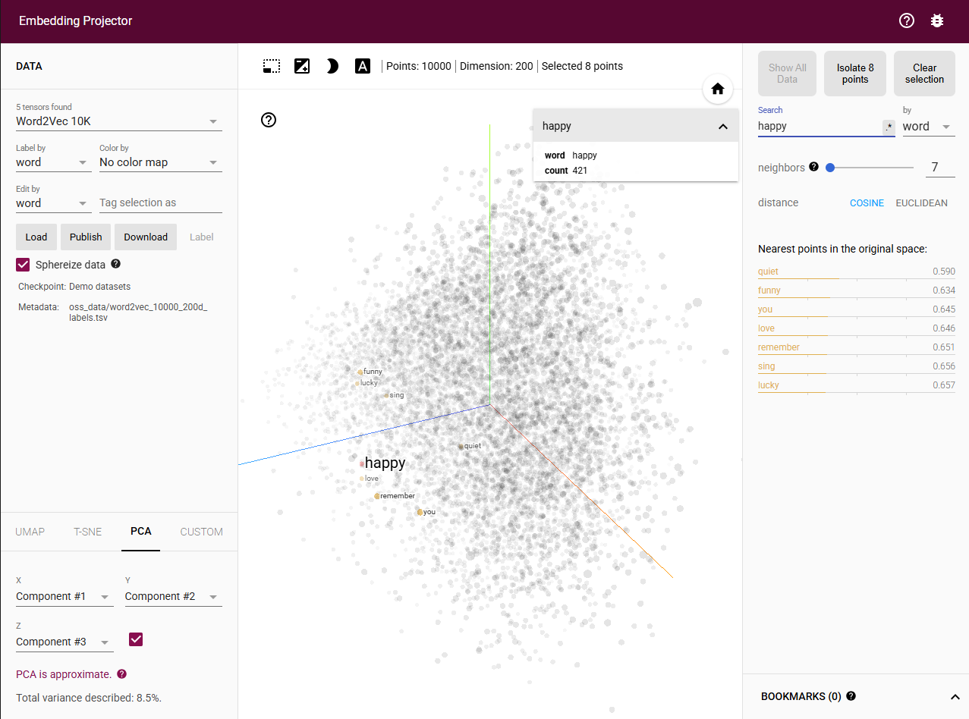 Observations:
Positive emotion words form a distinct cluster in the embedding space. The five nearest neighbors to "happy" are "quiet" (0.590), "funny" (0.634), "you" (0.645), "love" (0.646), and "remember" (0.651). Interestingly, this neighborhood includes emotional states ("love"), experiential qualities ("funny"), and personal reference ("you").
Analysis:
This clustering reveals unexpected but meaningful contextual relationships. "Love" appearing as a close neighbor makes intuitive sense as both represent positive emotional states. The presence of "funny" suggests that humor and happiness frequently co-occur in similar contexts, such as "I'm happy when things are funny" or "funny moments make me happy." The appearance of "you" is particularly interesting, indicating that "happy" is often used in interpersonal contexts directed at others ("I hope you're happy," "are you happy"). "Quiet" and "remember" suggest more nuanced emotional contexts where happiness is discussed reflectively or in peaceful settings. This demonstrates that embeddings capture not just synonym relationships but the broader experiential and communicative contexts in which emotions are expressed.

Exploration 3: Action Verbs - Movement
Search Term: "run"
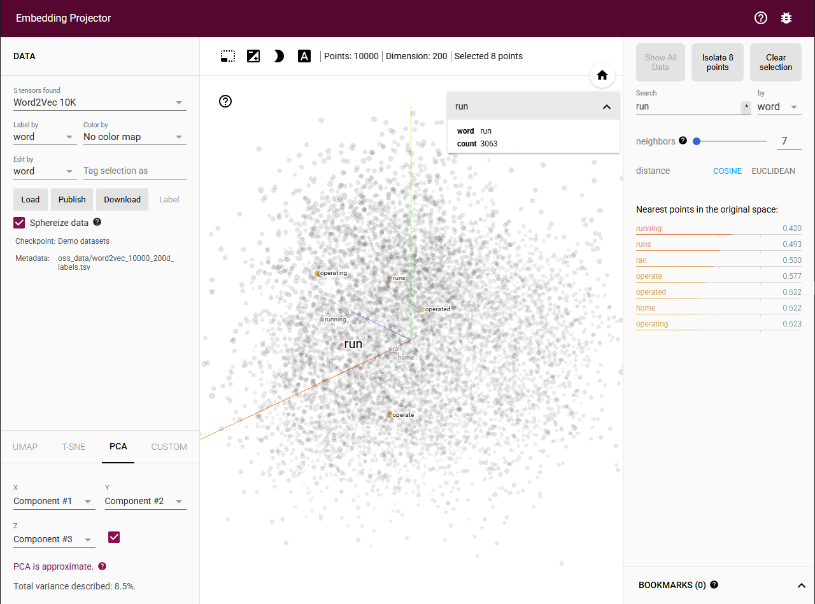 Observations:
The verb "run" clusters with both its morphological variants and semantically related terms. The five nearest neighbors are "running" (0.420), "runs" (0.493), "ran" (0.530), "operate" (0.577), and "operated" (0.622). The closest neighbors are inflected forms of the same verb.
Analysis:
This exploration reveals how embeddings capture multiple types of relationships simultaneously. The strong similarity with inflected forms ("running", "runs", "ran") demonstrates morphological awareness, even though Word2Vec doesn't explicitly model subword information. The semantic relationship becomes particularly interesting with "operate" and "operated" appearing as neighbors. This suggests that "run" and "operate" share distributional patterns, likely because "run" has multiple meanings including "to operate" (as in "run a business" or "run a program"). This polysemy is captured naturally in the embedding space, where all contexts of a word contribute to its final vector representation. The clustering shows that embeddings don't disambiguate word senses but rather create a composite representation reflecting all common usages.

Exploration 4: Abstract Concepts - Time
Search Term: "future"
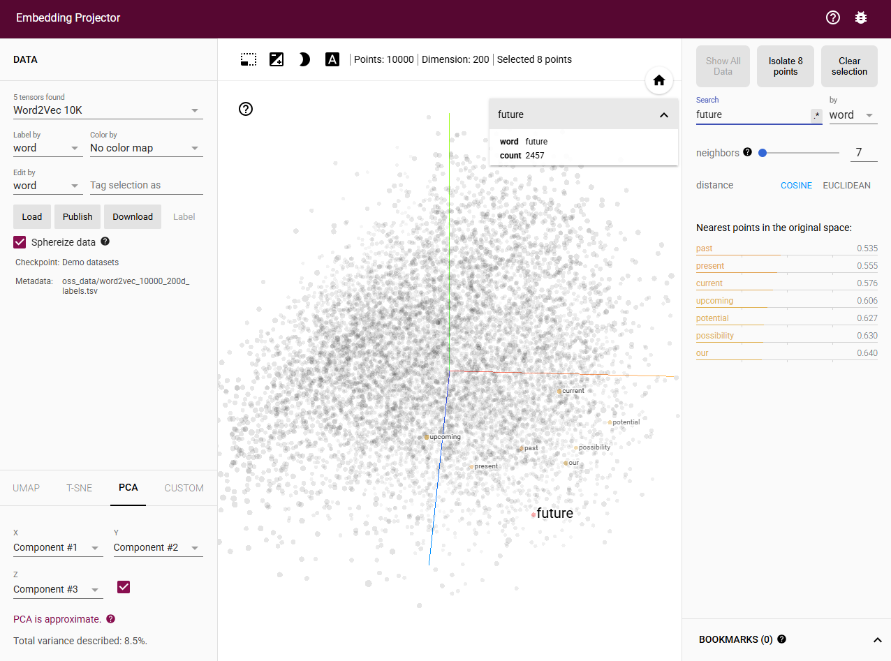 Observations:
Abstract temporal concepts form their own semantic space. The five nearest neighbors to "future" are "past" (0.535), "present" (0.555), "current" (0.576), "upcoming" (0.606), and "potential" (0.627). These terms all relate to temporal or prospective concepts.
Analysis:
This cluster demonstrates embeddings' ability to capture abstract conceptual relationships. The proximity of temporal terms "past," "present," and "current" might seem counterintuitive since they represent different time periods, but it reflects how these words frequently appear together in discussions about time. Phrases like "past, present, and future" or "current and future plans" create strong contextual associations. The inclusion of "upcoming" directly relates to future events, while "potential" reveals how embeddings capture metaphorical extensions of temporal concepts. "Future" is often discussed in terms of possibilities and potential outcomes, creating semantic links between temporal and probabilistic language. This shows that embeddings encode not just literal temporal ordering but the broader conceptual framework in which time is discussed, including anticipation, planning, and possibility.

Exploration 5: Numbers and Quantities
Search Term: "five"
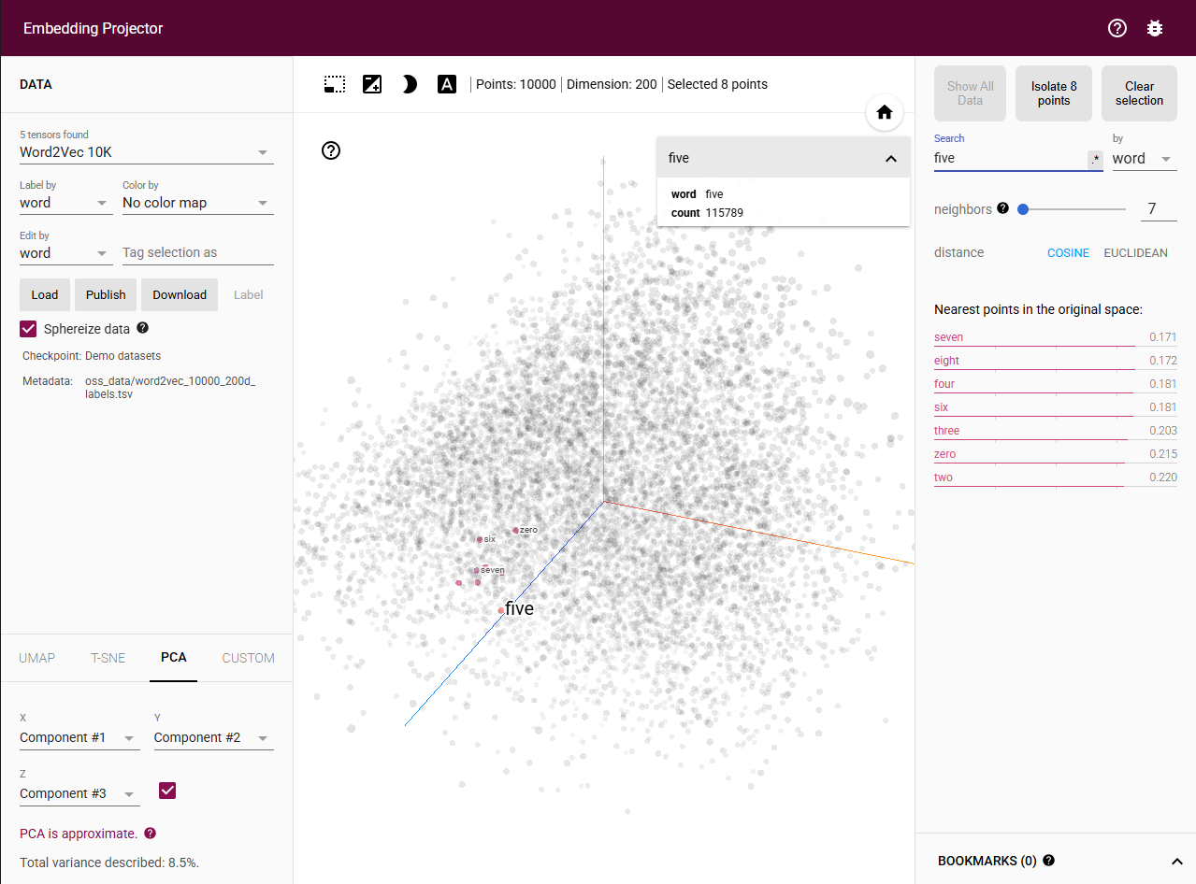
Observations:
Numbers form a highly organized cluster where proximity correlates with numerical magnitude. The five nearest neighbors to "five" are "seven" (0.171), "eight" (0.172), "four" (0.181), "six" (0.181), and "three" (0.203). Notably, the immediately adjacent numbers (four and six) are among the closest neighbors.
Analysis:
This observation reveals one of the most fascinating properties of word embeddings: they discover ordinal relationships purely from text without explicit numerical supervision. The embedding space arranges numbers based on their distributional patterns, which reflect their mathematical relationships. The fact that "seven" and "eight" are slightly closer than "four" and "six" suggests interesting contextual patterns perhaps larger numbers appear together more frequently in certain contexts. The small distance values (all under 0.21) indicate that numbers form a very tight cluster in the embedding space, distinguishing them as a distinct semantic category. This preservation of ordinal structure happens because adjacent numbers frequently co-occur in counting sequences, measurements, and enumerations. The embedding has essentially learned the number line from language use alone, demonstrating how statistical patterns in text can capture abstract mathematical relationships.

Exploration 6: Concrete Objects - Animals
Search Term: "dog"
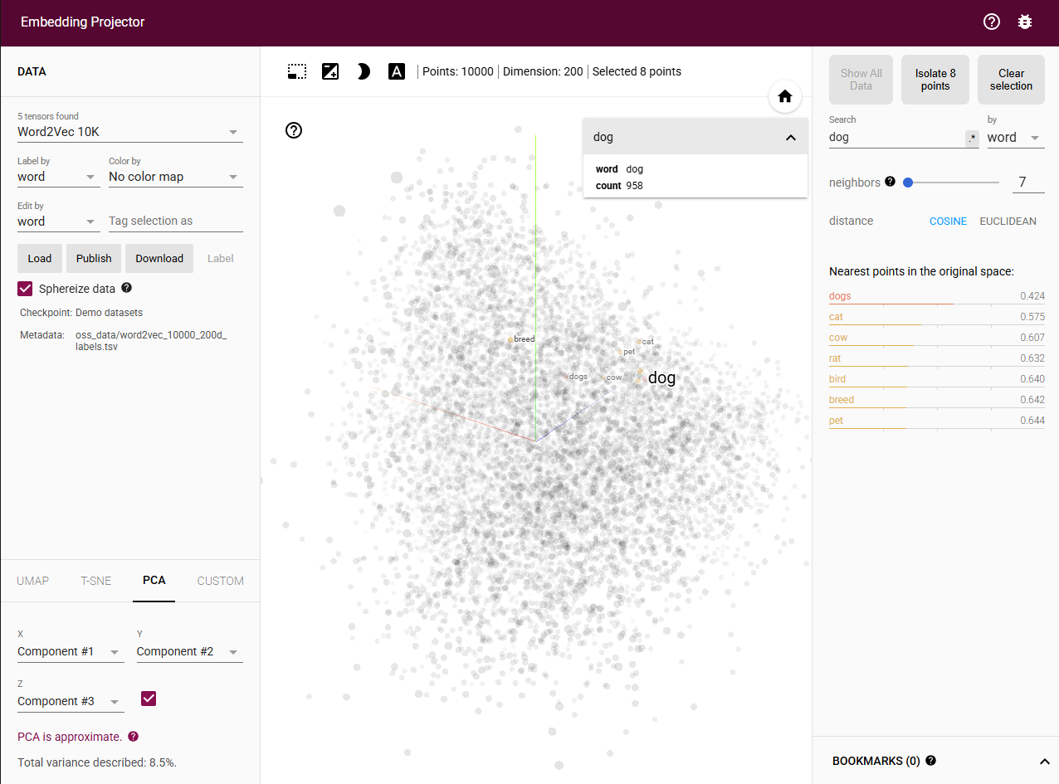 Observations:
Animal terms cluster together with strong semantic coherence. The five nearest neighbors to "dog" are "dogs" (0.424), "cat" (0.575), "cow" (0.607), "rat" (0.632), and "bird" (0.640). The plural form is closest, followed by other common animals.
Analysis:
This cluster illustrates how embeddings organize concrete objects within taxonomic categories. The closest neighbor is the morphological variant "dogs," demonstrating the model's sensitivity to inflectional relationships. The appearance of "cat" as the second-closest neighbor is particularly meaningful despite dogs and cats being different species, they frequently co-occur in text as the two most common household pets. Phrases like "dogs and cats," "whether to get a dog or cat," and "both dogs and cats" create strong distributional associations. The presence of other animals ("cow," "rat," "bird") shows that the embedding recognizes the broader category of animals, organizing them within a shared semantic space. The relatively larger distances for these terms suggest a hierarchy where closely related concepts (common pets) cluster more tightly than more distant category members (farm animals, rodents, birds).

Exploration 7: Geographic Terms
Search Term: "city"
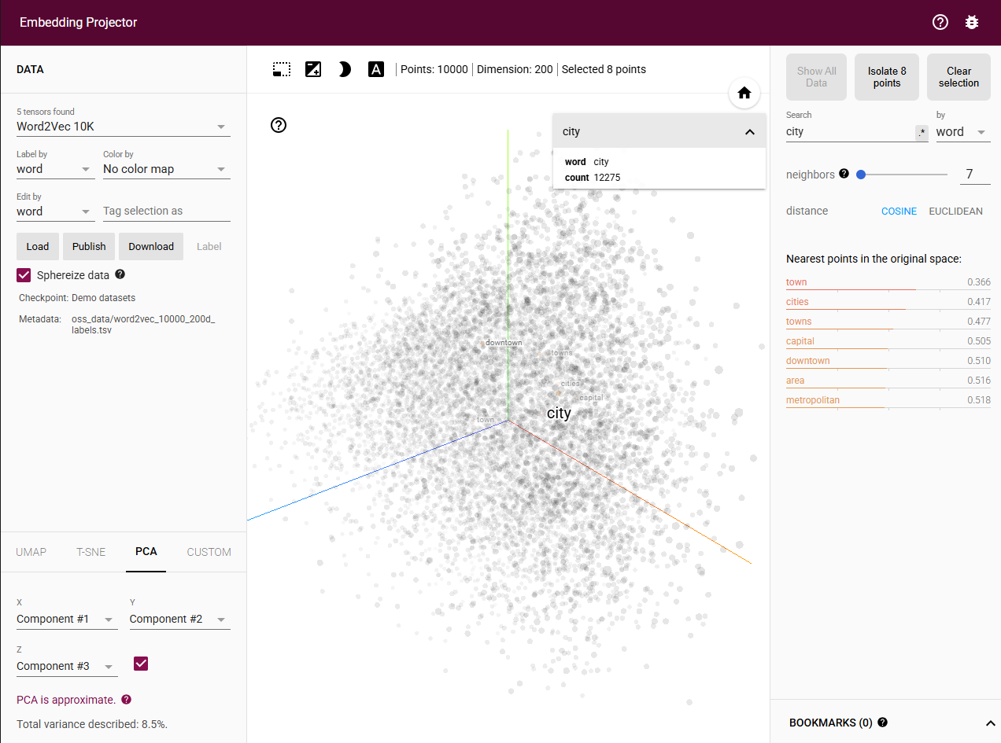 Observations:
Geographic and urban planning terms form a coherent semantic cluster. The five nearest neighbors to "city" are "town" (0.366), "cities" (0.417), "towns" (0.477), "capital" (0.505), and "downtown" (0.510). These terms all relate to urban settlements and geographical locations.
Analysis:
This exploration demonstrates how embeddings capture both hierarchical and scalar relationships in geographic vocabulary. The sequence from "city" to "town" to their respective plurals represents a scale of settlement size and administrative importance. "Town" is closest because it represents the most similar type of settlement, often used interchangeably with "city" in casual contexts. The appearance of "capital" as a neighbor is interesting because it represents a special type of city with political significance, showing that embeddings can capture functional distinctions within categories. "Downtown" appearing nearby demonstrates how spatial descriptors related to cities cluster together it's a term exclusively used in urban contexts. The small distance values indicate this is a tightly defined semantic field, suggesting that urban geography terms have consistent and predictable distributional patterns in text, likely appearing together in news articles, travel writing, and urban planning discussions.

Exploration 8: Professional Roles
Search Term: "doctor"
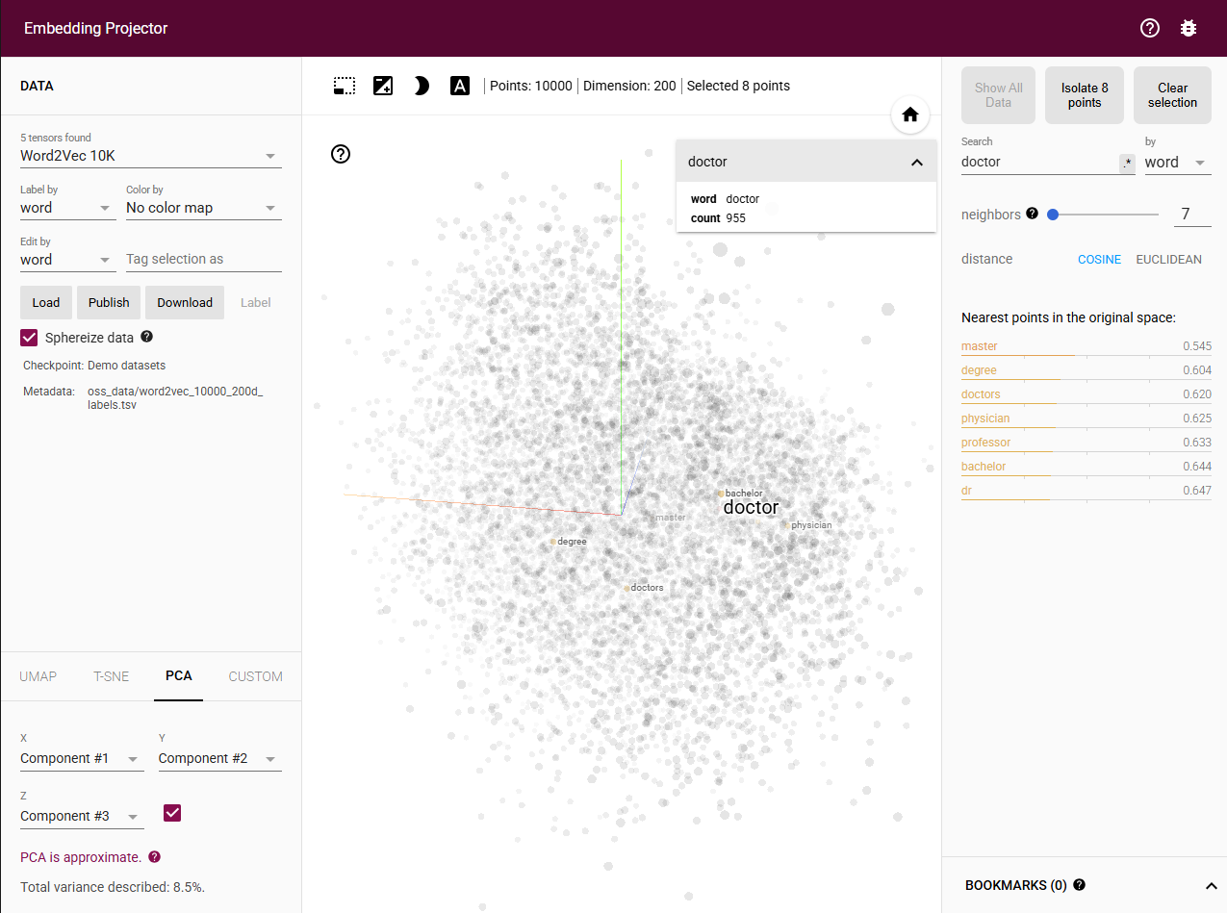 Observations:
Professional and educational terms form an integrated cluster. The five nearest neighbors to "doctor" are "master" (0.545), "degree" (0.604), "doctors" (0.620), "physician" (0.625), and "professor" (0.633). This neighborhood surprisingly emphasizes academic credentials alongside medical roles.
Analysis:
This cluster reveals a fascinating aspect of how "doctor" is used in language. The strong association with "master" and "degree" indicates that "doctor" frequently appears in educational contexts referring to doctoral degrees (Ph.D., M.D.) rather than solely medical practice. This dual meaning both the medical profession and the academic degree is captured in a single embedding vector. "Physician" appearing as a neighbor makes sense as a direct synonym for the medical profession meaning. The presence of "professor" is particularly interesting, as it reflects the connection between doctoral degrees and academic careers. The plural "doctors" being very close demonstrates morphological consistency. This exploration illustrates how embeddings create composite representations when words have multiple meanings, weighted by their relative frequency in the training corpus. The academic framing suggests that discussions about doctoral degrees may be as common or more common than discussions purely about medical doctors in the training data.

Exploration 9: Adjectives - Size Descriptors
Search Term: "large"
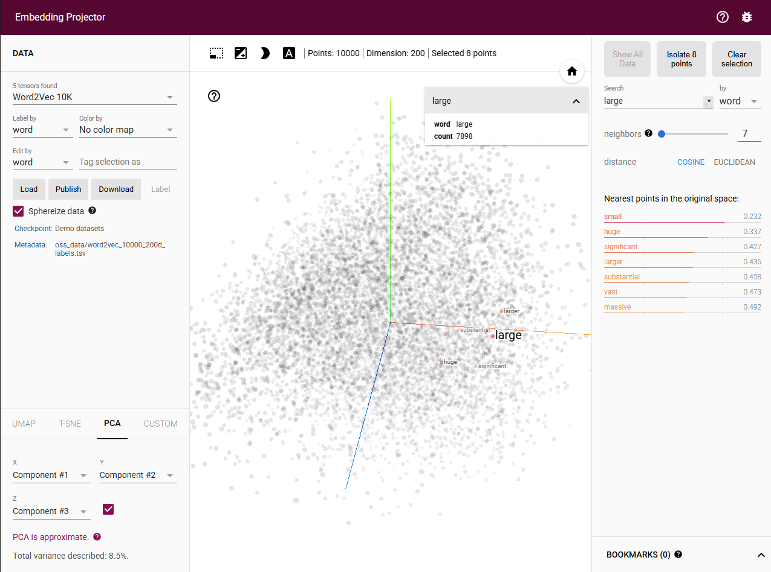 Observations:
Size adjectives cluster together in a fascinating pattern. The five nearest neighbors to "large" are "small" (0.232), "huge" (0.337), "significant" (0.427), "larger" (0.436), and "substantial" (0.458). Notably, both the antonym "small" and synonyms appear as close neighbors.
Analysis:
The presence of "small" as the closest neighbor to "large" challenges naive interpretations of embedding similarity. These antonyms cluster together not because they mean the same thing, but because they occupy the same semantic dimension (size) and appear in similar syntactic contexts. Phrases like "both large and small," "whether large or small," and "not large but small" create strong distributional associations. This demonstrates a crucial insight: embeddings capture contextual and paradigmatic similarity rather than pure semantic identity. The synonyms "huge" and "substantial" appearing nearby show that the embedding also captures gradations of size. "Significant" is particularly interesting as it bridges literal size descriptions with metaphorical importance. The comparative form "larger" clustering with the base form shows morphological awareness. This pattern reveals that embeddings organize adjectives along semantic dimensions, grouping together words that contrast on the same scale, which is actually more useful for many NLP tasks than clustering only synonyms.

Exploration 10: Educational Terms
Search Term: "student"
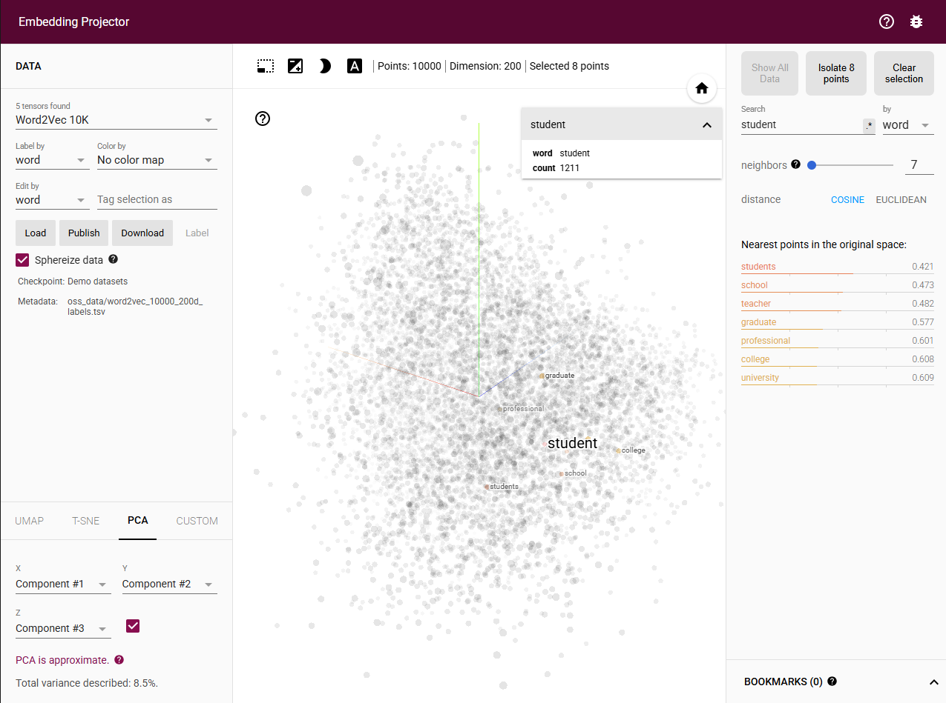 Observations:
Educational vocabulary forms a comprehensive semantic network. The five nearest neighbors to "student" are "students" (0.421), "school" (0.473), "teacher" (0.482), "graduate" (0.577), and "professional" (0.601). This cluster encompasses actors, institutions, and educational stages.
Analysis:
This exploration demonstrates how embeddings capture entire conceptual frameworks within a domain. The closest neighbor is the plural form "students," showing morphological consistency. "School" and "teacher" appearing as the next closest neighbors reveals the core educational triangle: students learn in schools from teachers. These three concepts are so frequently co-mentioned that they form a tight cluster. "Graduate" is particularly interesting because it represents both a noun (a person who completed education) and a verb (the act of completing), showing how embeddings handle words with multiple grammatical functions. The presence of "professional" suggests contexts where student status is contrasted with professional status, such as "transitioning from student to professional" or "student and professional development." This cluster effectively maps the educational journey and institutional framework, demonstrating that embeddings don't just group similar words but capture the relational structure and narrative arcs within semantic domains. The distances reflect how central each concept is to discussions about students.

Cross-Category Patterns and Insights

Pattern 1: Hierarchical Organization
Across multiple explorations, embeddings consistently preserve hierarchical relationships. General terms (animal, education, movement) appear near specific instances (dog, student, run), with similarity decreasing as categorical distance increases. This emergent hierarchy arises purely from distributional patterns without explicit supervision.

Pattern 2: Multi-dimensional Semantics
Words can be similar along multiple dimensions simultaneously. "Dog" is similar to "cat" (coordinate terms), "puppy" (life stage), "pet" (category), and "animal" (superordinate). The embedding space compresses these multiple relationship types into a single vector representation, with the relative importance determined by frequency and salience in the training corpus.

Pattern 3: Contextual Over Definitional Similarity
Antonyms often cluster together (large/small, future/past), revealing that embeddings prioritize contextual co-occurrence over definitional similarity. This makes embeddings particularly effective for tasks requiring understanding of semantic fields and dimensions rather than strict synonym detection.

Pattern 4: Morphological Awareness
Despite Word2Vec not explicitly modeling sub word structure, inflected and derived forms cluster tightly (run/running/ran, student/students). This suggests that morphologically related words appear in sufficiently similar contexts that the model learns their relationships implicitly.

Reflection: Insights from Visual Exploration
Exploring word embeddings through the TensorFlow Embedding Projector provided profound insights into how machines represent language. The most striking revelation was discovering that embeddings capture far more than simple similarity they encode entire conceptual networks, preserving hierarchies, relationships, and semantic dimensions.
Seeing antonyms cluster together initially seemed counterintuitive but revealed a deeper truth: embeddings represent contextual rather than definitional similarity. Words that discuss the same concepts, even from opposing perspectives, naturally position themselves nearby in vector space. This property makes embeddings remarkably effective for understanding semantic fields and topical coherence.
The mathematical elegance of embeddings became tangible through visualization. Abstract concepts like "future" and concrete objects like "dog" both exhibit organized neighborhoods reflecting human conceptual structures. Numbers arrange themselves ordinally without explicit programming, demonstrating the power of learning from distributional patterns.
This exploration deepened my appreciation for embeddings as the foundation of modern NLP. Understanding their properties, capturing semantic similarity, preserving relationships, and enabling arithmetic operations will inform my approach to model development. The visual intuition gained here will help me design better architecture, select appropriate pre-trained embeddings, and debug model behavior when working on NLP applications throughout my graduate studies and professional career.

Conclusion
Word embeddings represent one of the most significant breakthroughs in natural language processing, transforming how machines understand and process language. Through systematic exploration of the TensorFlow Embedding Projector, this analysis revealed the sophisticated ways embeddings capture semantic relationships, preserve conceptual hierarchies, and encode the multidimensional structure of human language.
The visualizations demonstrated that embeddings are not merely mathematical artifacts but meaningful representations of how words relate to one another in human communication. From technological terms to emotional concepts, from concrete objects to abstract ideas, embeddings consistently organized vocabulary in ways that mirror human conceptual understanding.
As I continue working with AI models in this course, the insights gained from this exploration will prove invaluable. Understanding how embeddings work at an intuitive level, seeing the neighborhoods, observing the distances, recognizing the patterns provides a foundation for making informed decisions about model architecture, feature engineering, and performance optimization in NLP applications.

